P1 – Matrix multiplication
Input: Two integer matrices, A and B (indexes start at 0,0 for rows and columns)
Output: Integer matrix C denoting the result of matrix multiplication between A and B.
Assumptions: Both matrices are square (have the same number of rows and columns).
Algorithm:
- initialize integer matrix C with all values set to 0
- current = 0
- for every row i in A:
  - for every column j in B:
    - for every column k in A (also every row k in B):
      - C[i][j] = C[i][j] + A[i][k] * B[k][j]
      - k = k + 1
    - j = j + 1
  - i = i + 1
- return C

P2 – In-place string reversal
Input: Character string S
Output: S reversed in place.
Assumptions: S uses a 0-based indexing system.
Algorithm:
- char = ‘’ // a character, will store temp values
- j = length of S - 1
- for character i in S
  - if ≤ i:
    - return S
  - char = S[i]
  - S[i] = S[j]
  - S[j] = char
  - j = j – 1
  - i = i + 1

P3 – Linked list insertion
Input: Integer int
Output: Nothing, int will be added to the end of the linked list L
Assumptions: Pointers and references exist
Algorithm:
- read user input int
- store int
- if this is the first value being stored:
  - do nothing
- else:
  - for element in L:
    - use pointer to move to next element

  - point pointer attached to previous element to location of int in memory
- create pointer that will hold address of next element

P4 – Recursive factorial
Input: Integer int
Output: Integer int representing the factorial of its original value
Base case: int is 1
Assumptions: int is greater than 0.
Algorithm:
- function factorial(int):
  - // base case
  - if int = 1:
    - return res
  - end if
  - // recursive case
  - return int * factorial(int – 1)

P5 – Linked list insertion
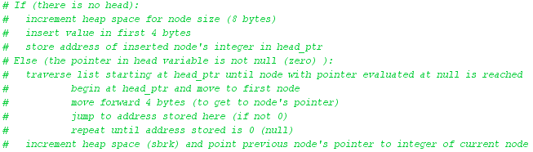
P6 – Linked list traversal/print
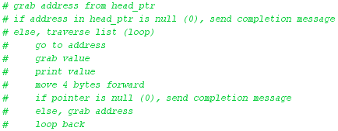
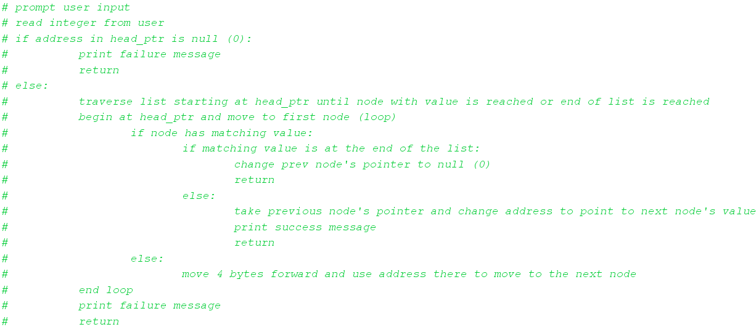
P7 – Linked list deletion

